CS303 Assignment 1

Ahmed Shahab

Prompt 1:

Prompt 2:

Creating users table

Creating locations table

Creating photographs table

Prompt 3

Altering locations table

Altering users table

Altering photographs table

Prompt 4:

CREATE UNIQUE INDEX idx_userid ON users (userid);

CREATE INDEX idx_photoid ON photographs (photoid);

Prompt 5

-- Inserting data into users table

INSERT INTO users (name, username, address, city, state, zip)

VALUES ('Bonnie Buntcake', 'bbunt', '6709 Wonder Street', 'Wonderbread', 'OH', 46106);

INSERT INTO users (name, username, address, city, state, zip)

VALUES ('Sam Smarf', 'ssmarf', '356 A Street', 'Beefy', 'PA', 19943);

INSERT INTO users (name, username, address, city, state, zip)

VALUES ('Wendy Grog', 'wgrog', '900 Star Street', 'Mary', 'MD', 21340);

INSERT INTO users (name, username, address, city, state, zip)

VALUES ('Joe Jogger', 'jjogger', '183713 N North Street', 'Norther', 'WV', 51423);

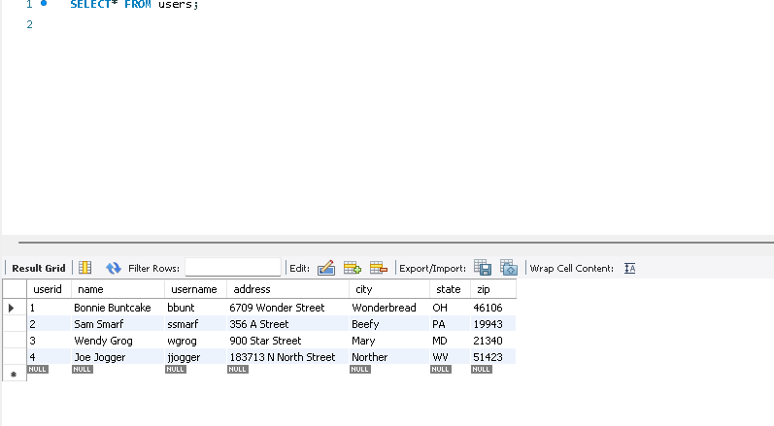

Prompt 6:

Prompt 7:

Prompt 8:

Tbh I have no idea what this question is asking. I think its something to do with normalization issues with the keys in the tables.

Prompt 9:

Prompt 10:

Query 11

Query 12:  
